END MODULE ASSIGNMENT MYSQL
END MODULE ASSIGNMENT MYSQL

NAME:Mohamed Fathima . Y
DATE:19/09/2026

PROJECT TITLE
E-Commerce Customer Churn Analysis

Problem Statement:

In the realm of e-commerce, businesses face the challenge of understanding customer churn patterns to ensure customer satisfaction and sustained profitability. This project aims to delve into the dynamics of customer churn within an e-commerce domain, utilizing historical transactional data to uncover underlying patterns and drivers of
churn. By analyzing customer attributes such as tenure, preferred payment modes,satisfaction scores, and purchase behavior, the project seeks to investigate and understand the dynamics of customer attrition and their propensity to churn. The ultimate objective is to equip e-commerce enterprises with actionable insights to implement targeted retention strategies and mitigate churn, thereby fostering long-term customer relationships and ensuring business viability in a competitive landscape.

Dataset Download:

https://drive.google.com/uc?export=download&id=1iKKCze_Fpk2n_g3BIZBiSjcDFdFcEn3D

Project Steps and Objectives

Data Cleaning

Handling Missing Values and Outliers:

- Question: Impute mean for the following columns, and round off to the nearest integer if required: WarehouseToHome, HourSpendOnApp,
OrderAmountHikeFromLastYear,DaySinceLastOrder.
Impute mode for the following columns: Tenure, CouponUsed, OrderCount.

- What I Did: Filled in all missing values in both numerical and categorical columns.

- ​How I Did It: For numerical columns (WarehouseToHome, HoursSpentOnApp, OrderAmountHikeFromLastYear, and DaySinceLastOrder), I calculated their rounded average values and updated the missing entries. For categorical/discrete columns (Tenure, CouponUsed, and OrderCount), I identified the most frequently occurring value (mode) and used it to fill in the missing entries.

Screenshort:

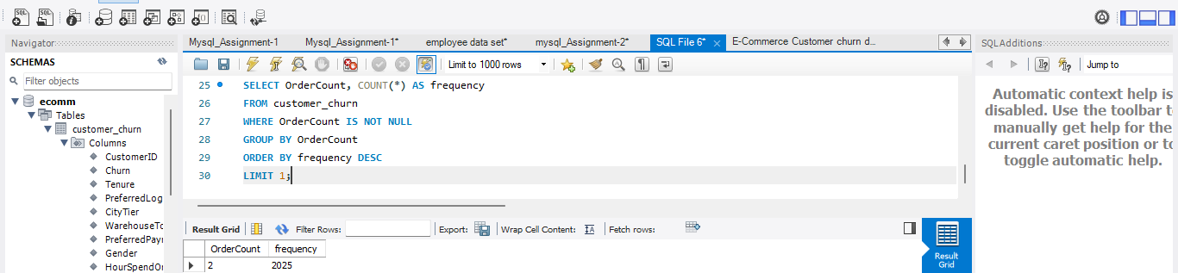
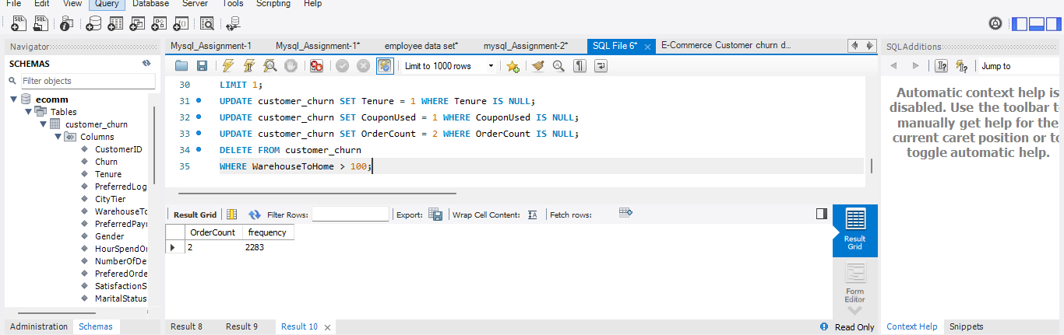

- Question:Handle outliers in the 'WarehouseToHome' column by deleting rows where the values are greater than 100.

- ​What I Did: Cleaned up extreme distance values that could distort the analysis.

- ​How I Did It: Identified and deleted all table rows where the WarehouseToHome distance exceeded 100 km.

Screenshot:

Dealing with Inconsistencies:

- Question: Replace occurrences of “Phone” in the 'PreferredLoginDevice' column and“Mobile” in the 'PreferedOrderCat' column with “Mobile Phone” to ensure uniformity.
Standardize payment mode values: Replace "COD" with "Cash on Delivery" and
"CC" with "Credit Card" in the PreferredPaymentMode column.

- ​What I Did: Standardized abbreviated and inconsistent text labels across login devices, order categories, and payment methods.

- ​How I Did It: Updated column records directly by replacing terms like "Phone" with "Mobile Phone", "Mobile" with "Mobile Phone", "COD" with "Cash on Delivery", and "CC" with "Credit Card".

Screenshot:
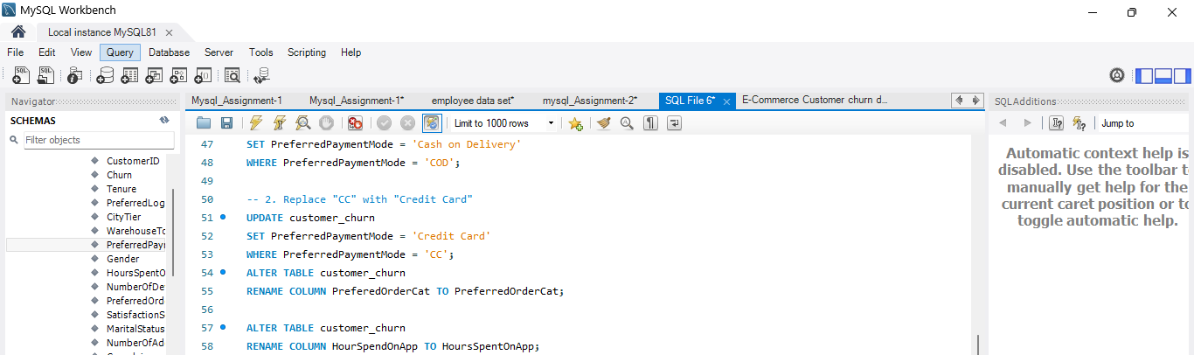

Data Transformation

Column Renaming:

- Question : Rename the column "PreferedOrderCat" to "PreferredOrderCat".
Rename the column "HourSpendOnApp" to "HoursSpentOnApp".

- What I Did: Corrected spelling mistakes in the column headers.

- ​How I Did It: Renamed PreferedOrderCat to PreferredOrderCat and HourSpendOnApp to HoursSpentOnApp in the table structure.

Screenshot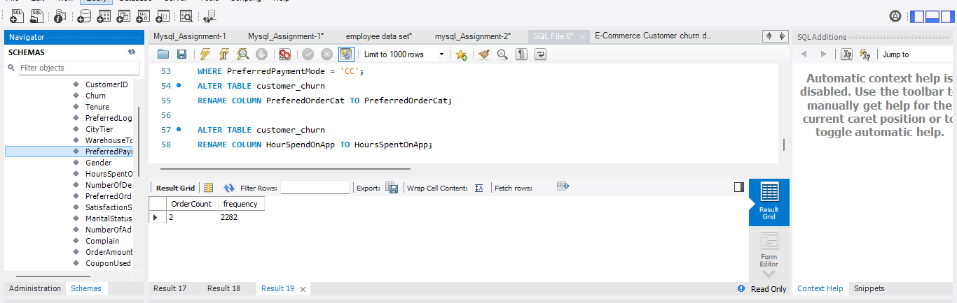

Creating New Columns:

- Question : Create a new column named ‘ComplaintReceived’ with values "Yes" if the corresponding value in the ‘Complain’ is 1, and "No" otherwise.
Create a new column named 'ChurnStatus'. Set its value to “Churned” if the
corresponding value in the 'Churn' column is 1, else assign “Active”.

- What I Did: Added user-friendly, descriptive text status columns to replace numeric binary flags.

- ​How I Did It: Created ComplaintReceived to show "Yes" or "No" based on the original complaint indicator, and created ChurnStatus to show "Churned" or "Active" based on the original churn indicator.

Screenshot: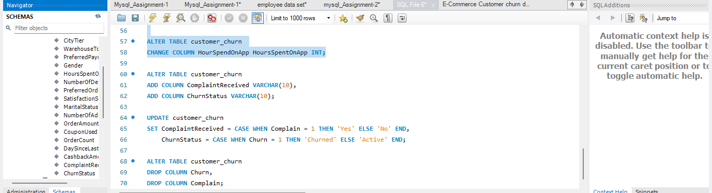

Column Dropping:

- Question : Drop the columns "Churn" and "Complain" from the table.

- ​What I Did: Cleaned up the database schema by removing duplicate data.

- ​How I Did It: Deleted the old binary Churn and Complain columns since they were replaced by the new descriptive status columns.

Screenshot:

Data Exploration and Analysis:

- Retrieve the count of churned and active customers from the dataset.
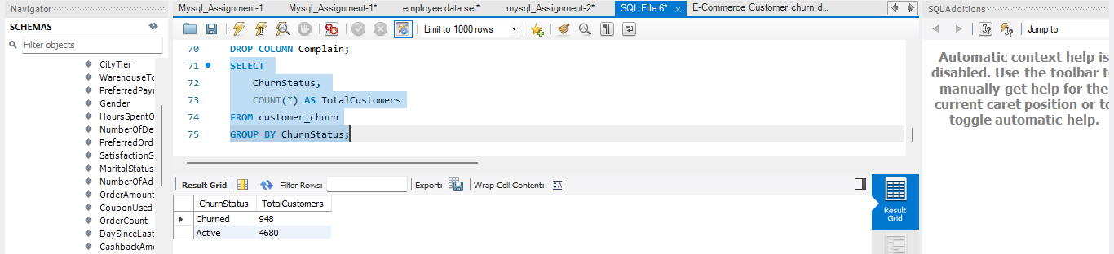

- Display the average tenure and total cashback amount of customers who
churned.
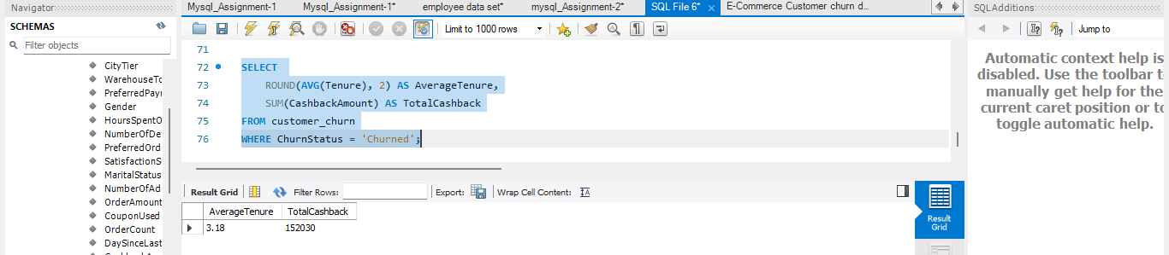

- Determine the percentage of churned customers who complained.
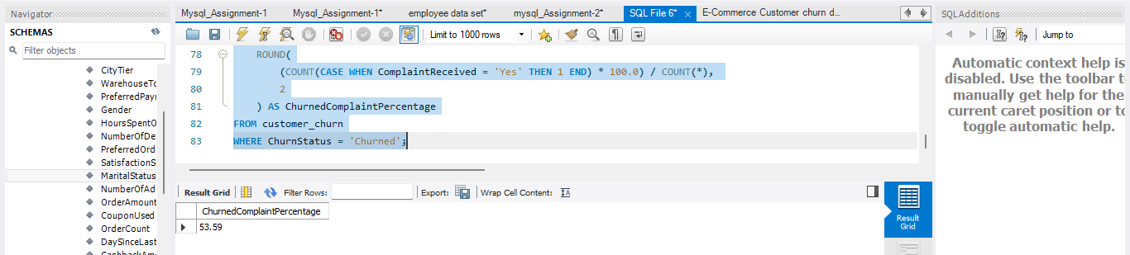

- Identify the city tier with the highest number of churned customers whose
The preferred order category is Laptop & Accessory.
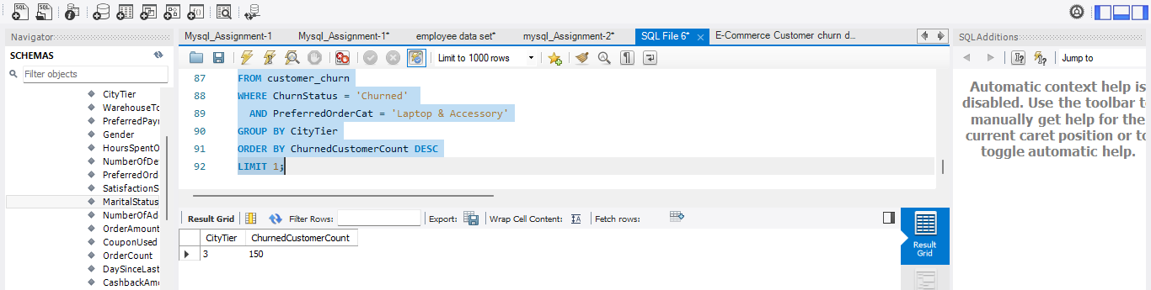

- Identify the most preferred payment mode among active customers.
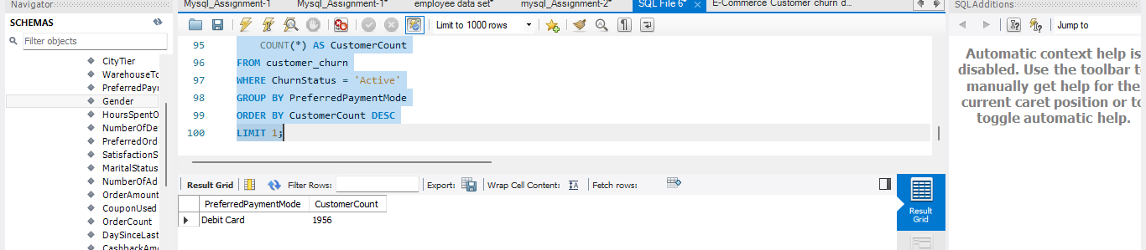

- Calculate the total order amount hike from last year for customers who are single and prefer mobile phones for ordering.
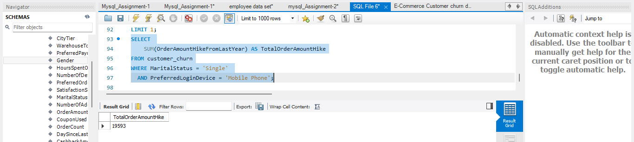

- Find the average number of devices registered among customers who used UPI as their preferred payment mode.
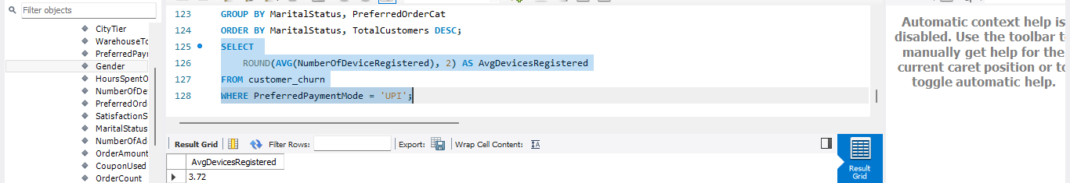

- Determine the city tier with the highest number of customers.
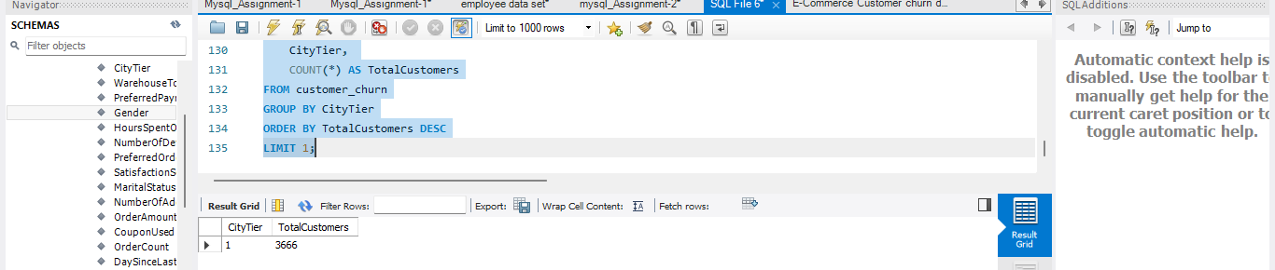

- Identify the gender that utilized the highest number of coupons.
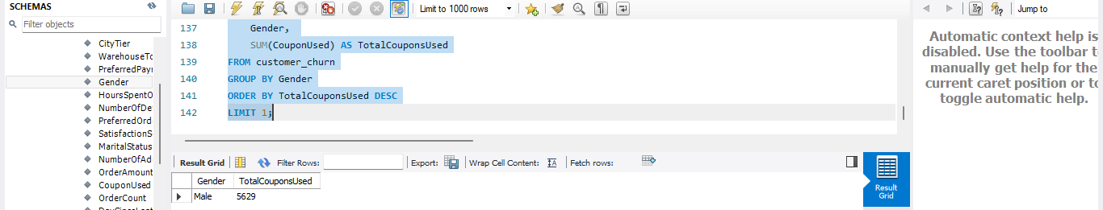

- List the number of customers and the maximum hours spent on the app in each preferred order category.
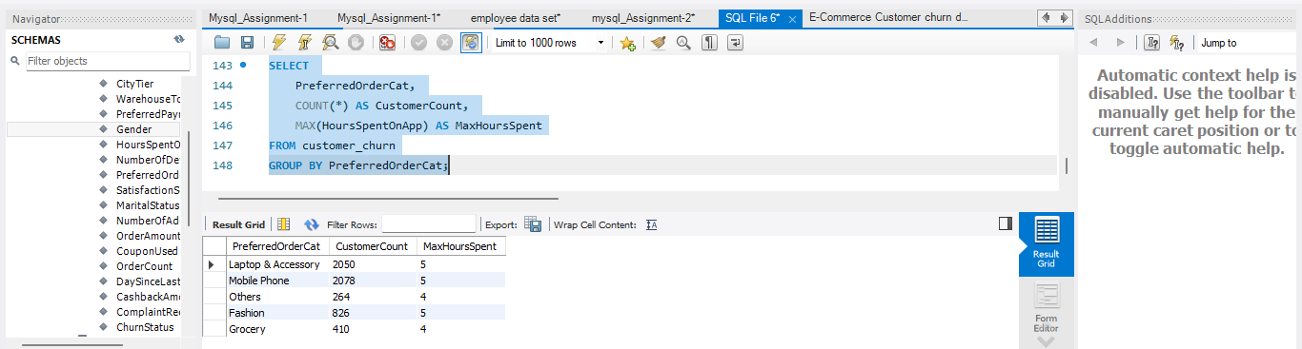
- Calculate the total order count for customers who prefer using credit cards and have the maximum satisfaction score.
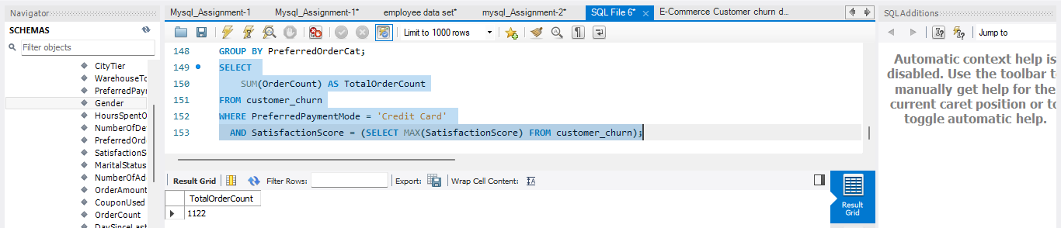

- What is the average satisfaction score of customers who have complained?
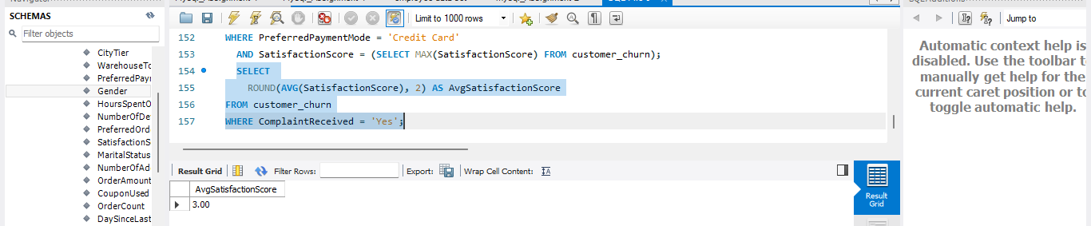

- List the preferred order category among customers who used more than 5
Coupons.
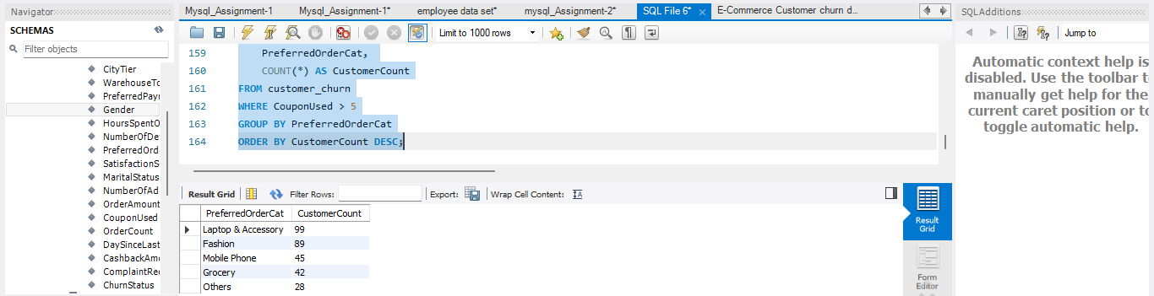

- List the top 3 preferred order categories with the highest average cashback amount.
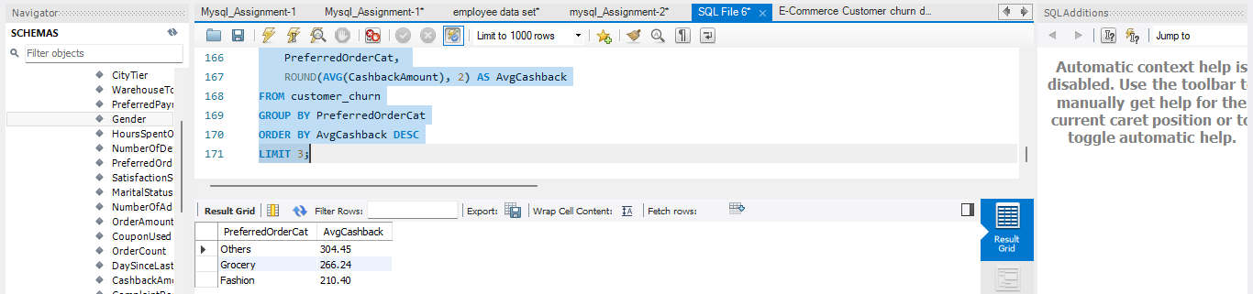

- Find the preferred payment modes of customers whose average tenure 10
months and have placed more than 500 orders.

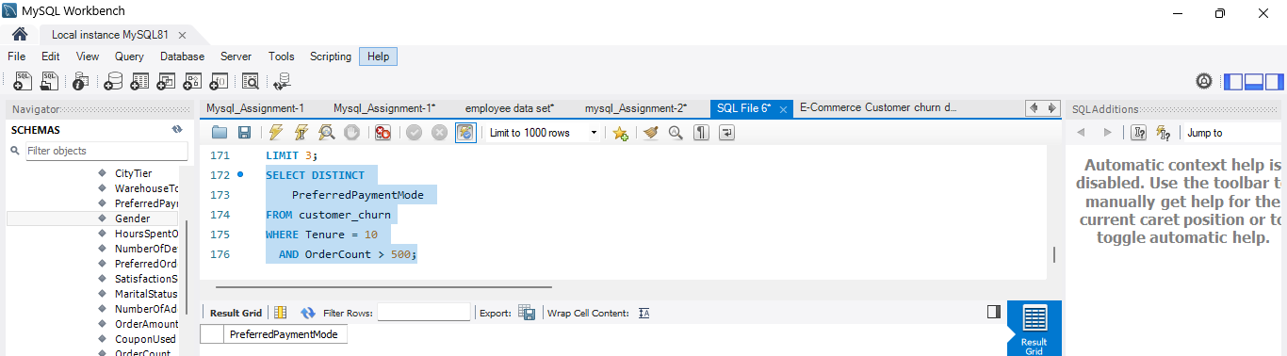

- Categorize customers based on their distance from the warehouse to home such as 'Very Close Distance' for distances <=5km, 'Close Distance' for <=10km, 'Moderate Distance' for <=15km, and 'Far Distance' for >15km. Then, display the churn status breakdown for each distance category.

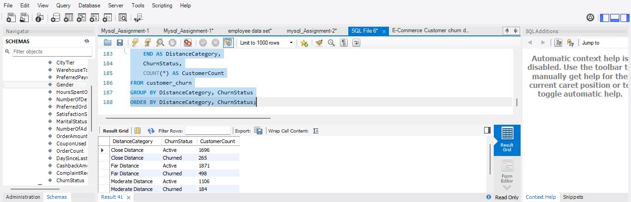

- List the customer’s order details who are married, live in City Tier-1, and their order counts are more than the average number of orders placed by all Customers.
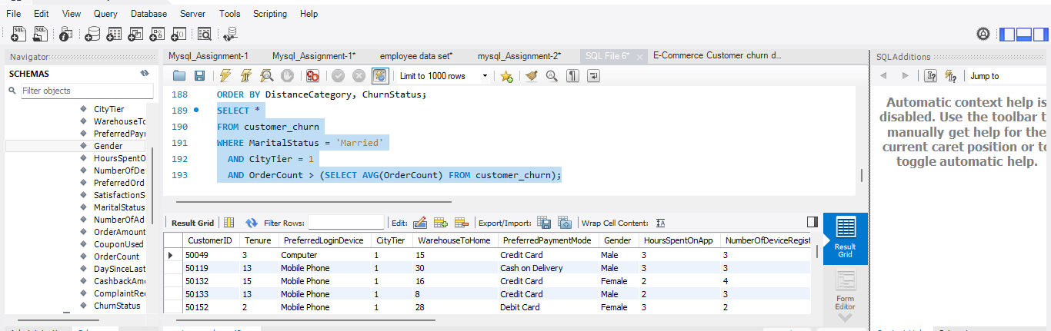

a) Create a ‘customer_returns’ table in the ‘ecomm’ database and insert the
following data:
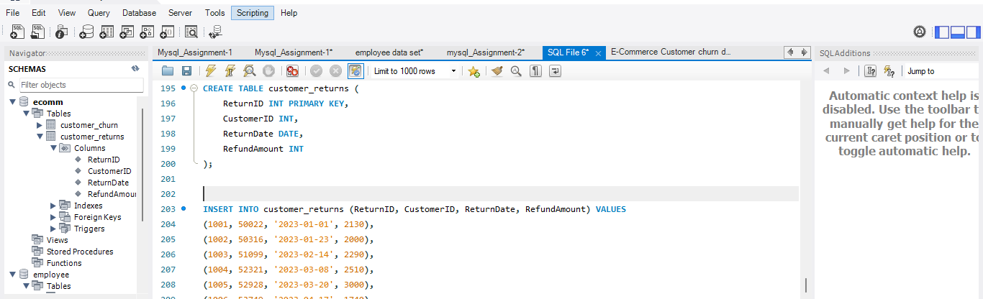

b) Display the return details along with the customer details of those who have
churned and have made complaints.
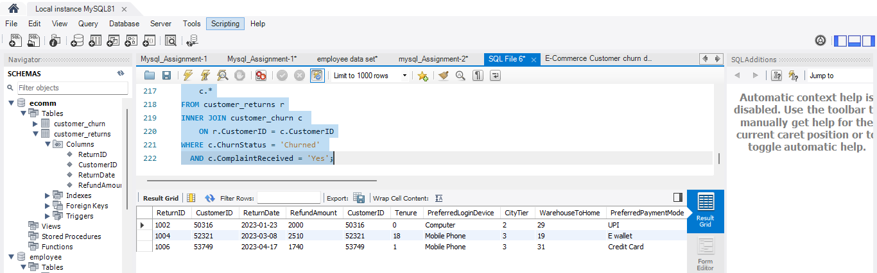

Conclusion

​This project successfully cleaned, transformed, and analyzed the e-commerce customer churn dataset using MySQL. By addressing missing values, handling distance outliers, and standardizing categorical fields, the dataset was prepared for accurate relational analysis.
​The analytical insights reveal that customer complaints and warehouse distance strongly correlate with higher churn rates. Furthermore, joining return data highlighted key areas for service improvement. Overall, the project demonstrates how structured SQL queries can transform raw transactional records into actionable business intelligence to support customer retention strategies.

OUTPUT:
